Your Hourglass of Offerings
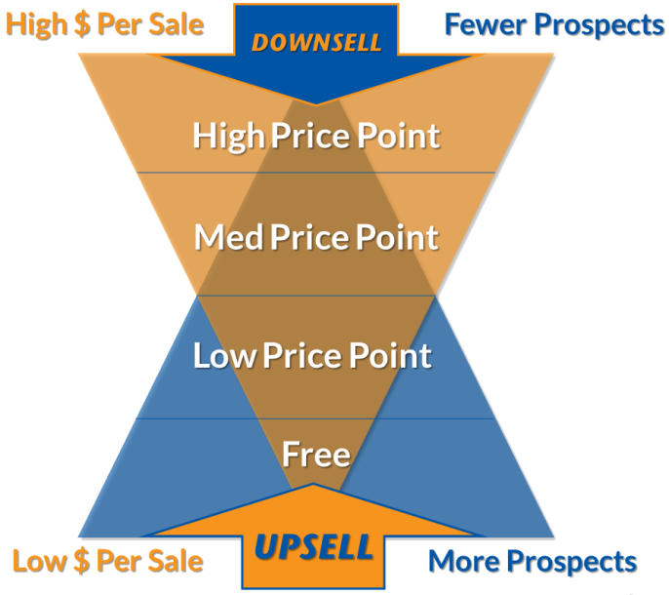

Your High Price Point Offering(s) - Roughly $500-10,000+
Name of Offering(s): (working title is fine)
Price(s) and your reasoning for it:

Packaging/features/ benefits:

Delivery method(s): (Online? In person? 1:1? Group? Physical product mailed?)
Your Medium Price Point Offering(s) - Roughly $100-$500
Name of Offering(s):
Price(s) and your reasoning for it:

Packaging/features/ benefits:

Delivery method(s):
Your Low Price Point Offering(s) – Roughly $10-100
Name of Offering(s):
Price(s) and your reasoning for it:

Packaging/features/ benefits:

Delivery method(s):
Your FREE Offering(s) - $0
Name of Offering(s):
Packaging/features/ benefits:

Delivery method(s):
Other Thoughts/Questions to Capture:

